School exchange to Ribe-Denmark (March 2019)

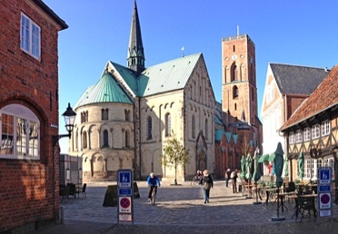
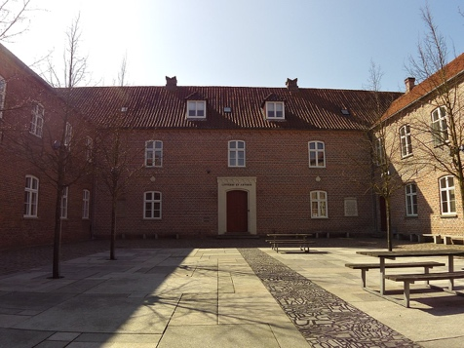
The Danish students had visited us in September 2018, we now paid them a visit. Our trip started early in the morning on 18th March. We started our train journey to Ribe at Büchen train station. It took us about 4 ½ hours and it wasn’t really complicated or full of stress. After we had arrived in Ribe we took a 10-minute walk to our hostel. There we had time to set up our rooms (we had rooms of 3-4) and took a first walk around the city. Around 6pm we went to our partner school (´´Ribe Katedralskole´´) which was pretty central in Ribe and about 10 minutes away from our hostel. The school was built in an old-fashioned design from the outside, with a main building, a schoolyard in the front and smaller buildings scattered around and behind it. We later learnt that each building was for a specialized school class (business, art, etc.). Despite the very old-looking front, the classrooms were modern and had a technological furnishing (projector, white board, …). We also learnt that each student had to buy their own laptops for school. So, on the first evening after having met each other we ate pizza together and then presented our collages about ourselves in small groups of 4. After that the Danes showed us their school in small groups. On Tuesday we had presentations about companies which the Germans held in English and the Danes in German. We also answered a few German questions together, again in small groups of 4 (2 Germans, 2 Danes), before we participated in a little sport ´´tournament´´ (we played elephant soccer and a kind of hockey against each other in teams). That was it for the day and we took a closer look around the city on our own. On Wednesday we had a tour in a company called ‘’Lyndahl’’ which produced tubes for different kinds of purposes (garden, fire Department, etc.). The tour was about 90 minutes long and we had to walk to it for about 40 minutes. Nearby there was a Burger King, so naturally (at least for people at our age, I guess) we stopped there afterwards. In the afternoon our teachers organised a city tour for us. An older tour guide showed us round the oldest city of Denmark. It was really interesting to learn about its history and we had the chance to climb the church tower which was about 15 floors high. As one might imagine, we all were pretty done once we reached the top. But if we thought that was it with sports for the day, we were wrong because at around 9pm we had a climbing class at the gym (there was one right at the hostel). On the last day we just had to pack, clean the rooms and meet up for a little feedback. After that we already took the train back home. We reached Büchen around 5pm, all safe and sound.

